December Bible Study Opening

348 The King Shall Come When Morning Dawns
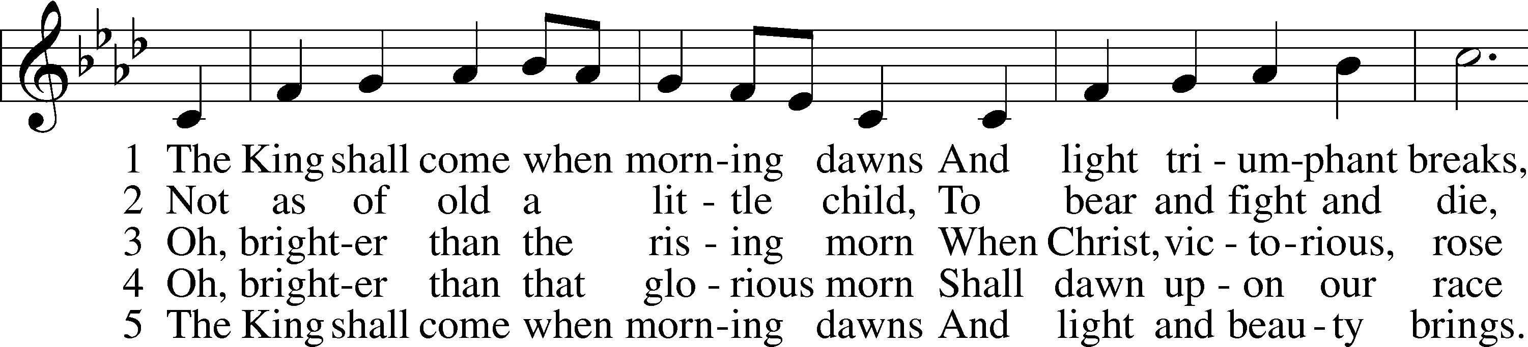
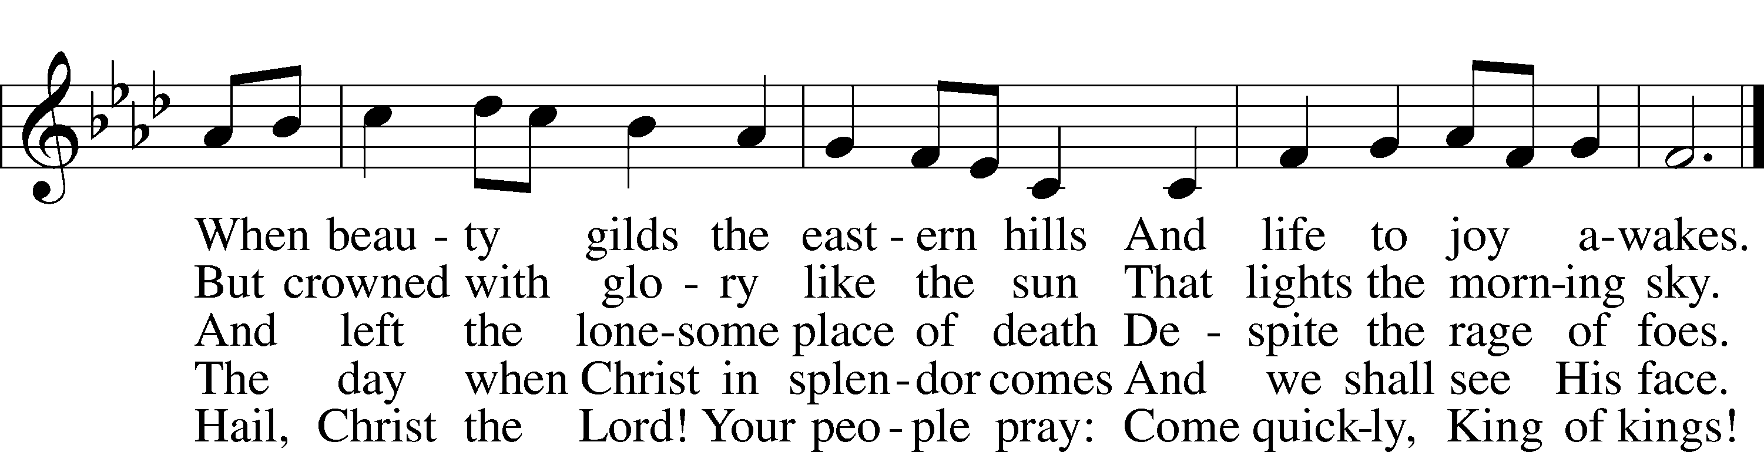

The Seventh Commandment
You shall not Steal.
What does this mean? We should fear and love God so that we do not take our neighbor’s money or possessions, or get them in any dishonest way, but help him to improve and protect his possessions and income.

The Eighth Commandment
You shall not give false testimony against your neighbor.
What does this mean? We should fear and love God so that we do not tell lies about our neighbor, betray him, slander him, or hurt his reputation, but defend him, speak well of him, and explain everything in the kindest way.

The Ninth Commandment
You shall not covet your neighbor’s house.
What does this mean? We should fear and love God so that we do not scheme to get our neighbor’s inheritance or house, or get it in a way which only appears right, but help and be of service to him in keeping it.

The Tenth Commandment
You shall not covet your neighbor’s wife, or his manservant or maidservant, his ox or donkey, or anything that belongs to your neighbor.
What does this mean? We should fear and love God so that we do not entice or force away our neighbor’s wife, workers, or animals, or turn them against him, but urge them to stay and do their duty.

Memory Verse
Isaiah 9:6 – For to us a child is born, to us a son is given; and the government shall be upon his shoulder, and his name shall be called Wonderful Counselor, Mighty God, Everlasting Father, Prince of Peace.
Prayer: Holy and merciful God, You have taught us what You would have us do and not do. Pour out Your Holy Spirit on us so that He may bear fruit in our lives and that, remembering Your mercies and Your laws, we may grow in obedience to Your will and in love for You and our neighbor. Help us to follow the example of Your dear Son, Jesus Christ, our Lord, in whose name we pray. Amen.

